Module 9 - CSS Step 08

**Home Page:**

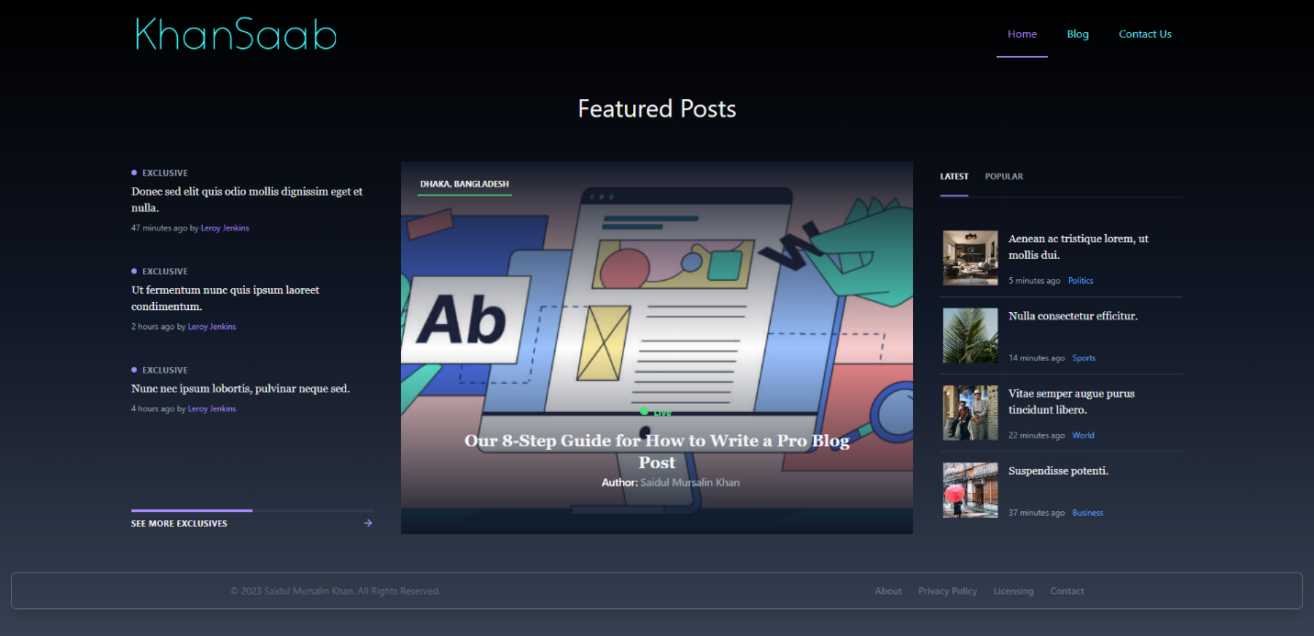

**Blog:**

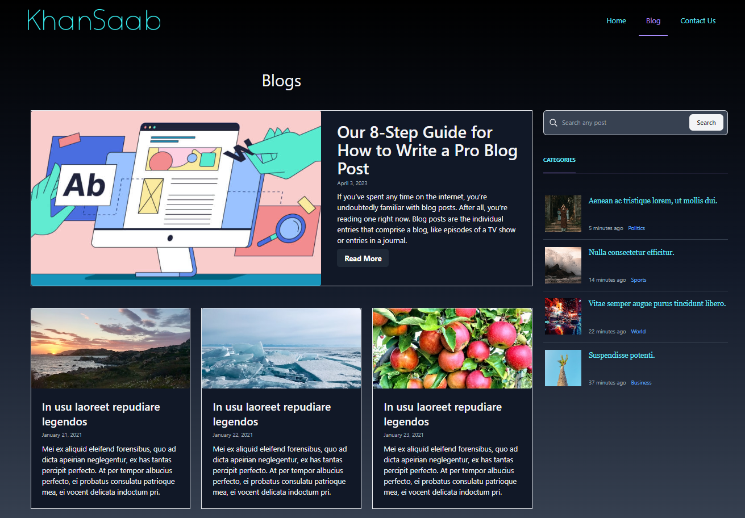

**Contact Us:**

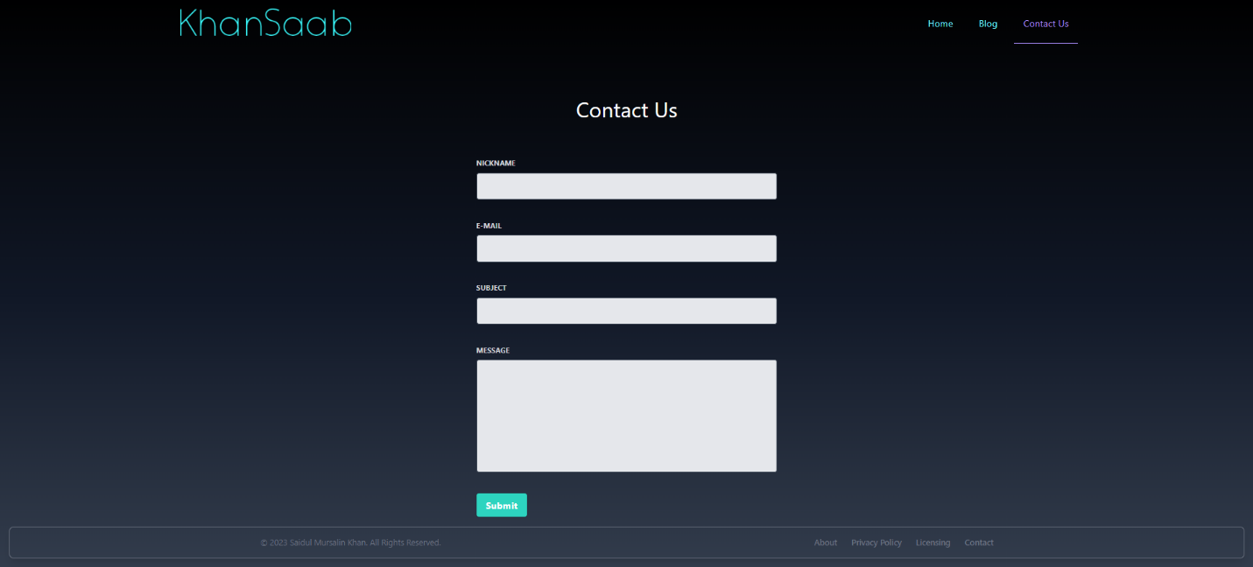

**Post:**

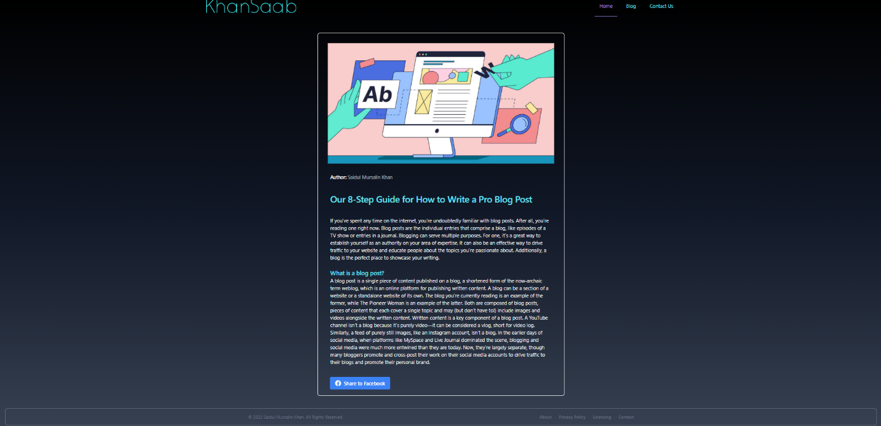

I have used Tailwind CSS to create a responsive blog website. I have used flex to position the layout. All the requirements have fulfilled. Contact form data is stored in a csv file. I have faced a challenge to implement the social media sharing button and make it work. I also faced challenge to create featured post section. I have learned more about how the flexbox works in Tailwind CSS. As I have previous experience of tailwind css so I did not find that much difficulties.